Daniel Fryer
Assignment 8.2
2/21/2026
Flow Chart:
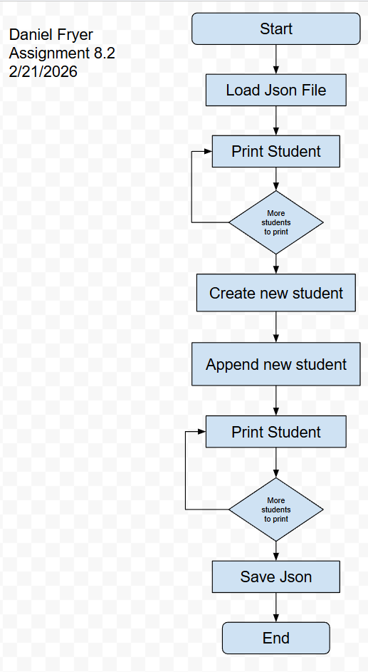

Program Output:
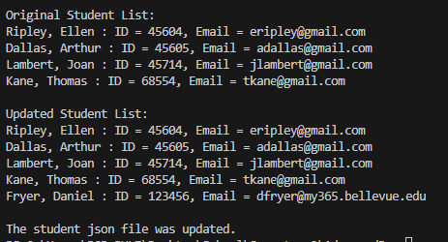
Error message:
No matter what I did I couldn’t get a popup warning me to reload the file. I left the json file open in VS code and it still updated the file but never asked me to reload.

JSON file:
[
{
"F_Name": "Ellen",
"L_Name": "Ripley",
"Student_ID": 45604,
"Email": "eripley@gmail.com"
},
{
"F_Name": "Arthur",
"L_Name": "Dallas",
"Student_ID": 45605,
"Email": "adallas@gmail.com"
},
{
"F_Name": "Joan",
"L_Name": "Lambert",
"Student_ID": 45714,
"Email": "jlambert@gmail.com"
},
{
"F_Name": "Thomas",
"L_Name": "Kane",
"Student_ID": 68554,
"Email": "tkane@gmail.com"
},
{
"F_Name": "Daniel",
"L_Name": "Fryer",
"Student_ID": 123456,
"Email": "dfryer@my365.bellevue.edu"
}
]

